REQUIREMENTS ANALYSIS REPORT

**1. introduction**

The purpose of this proposed project is to develop an IoT platform that will monitor the available parking spaces in a parking structure. In efforts to help reduce the amount of time taken to find available spaces, this system would be developed to help alleviate the amount of time it takes for people to find a space to park their vehicles by managing and displaying available spaces.

**2. Overall system concept**

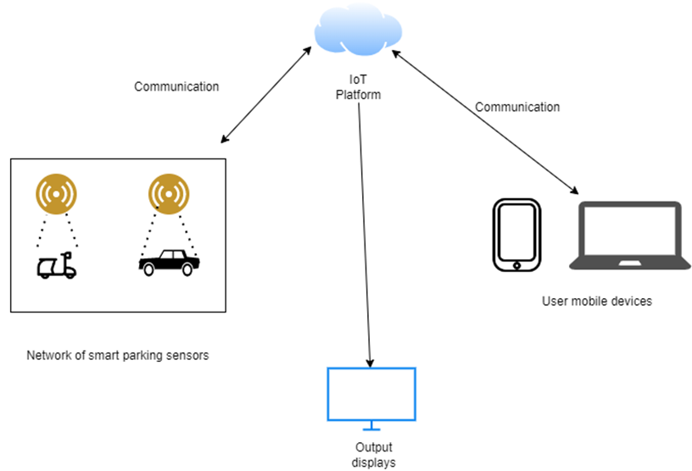

**3. Operations overview**

The proposed IoT Platform will be designed on a based Ubuntu server. The platform is intended to be using LAMP stack and MySQL. The message broker that will be used is going to be MQTT (MQ Telemetry Transport). To provide constant updates about statuses of the parking sensors, communication between the platform and sensors should be relaying data transfers at the maximum speed required. The rule engine will be designed and serve as the platforms block for rules and conditions.

**Diagram of IoT Platform blocks:**

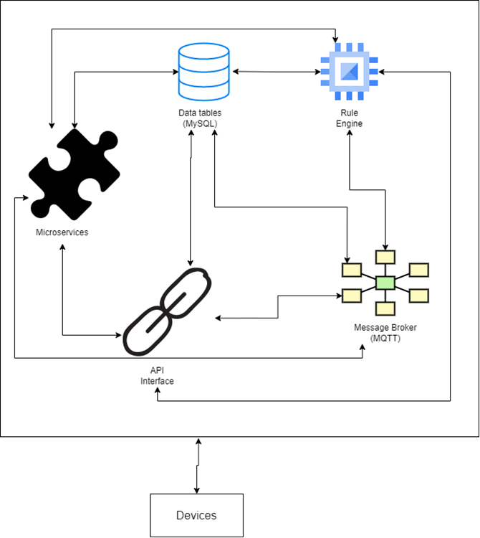

**4. System constraints**

a. Hardware availability

Proximity devices must have IEEE 802.3ac (WiFi) capabilities

Wireless networks must be able to support a large number of proximity devices

b. Operating system limitations

Must be able to support IoT processes and MQTT protocols

The OS is limited to allocation of 2GB of RAM

c. Support software limitations

Cloud instance must contain 50 GB of storage and 2GB of RAM

Message broker must be able to route messages efficiently

Message broker must be able to handle 25 messages per second

**5. Performance estimates**

* Wireless communications between the proximity devices and the network gateways will be communicating at 2.4 GHz or 5 GHz based on IEEE 802.3ac standards.
* Data transfer speeds are estimated to be at least 1Gbps.
* The amounts of messages handled per second by the message broker is estimated to be at 25 messages per second.

**6. Development assumptions**

* For the development of this project, it is assumed that the total costs of development will be around or below the expected budget.
* It is also assumed that conflicts throughout the project will occur at a minimum.
* The schedule of the project has been slightly overexaggerated to account for any minor setbacks that could occur during the development process.
* All components of the IoT platform will work as expected and meet performance requirements
* All proximity devices and network gateways will work as expected and meet performance requirements.

**7. Risks to both costs and schedules**

* IoT Platform change of requirements – Any changes to the platform requirements will cause delays in the schedule and delay of product deployment.
* Delay of shipment of required hardware – Any unforeseen delays of shipments for the necessary hardware such as vehicle proximity sensors and network gateways would cause delays in the schedule and delay of product deployment.
* Database security risks – The security of the database in the IoT platform may have unforeseen risks that could affect the confidentiality and integrity of the database. It must be assured that all vulnerabilities are to be patched so that unauthorized access to the database is prevented and the data in the database cannot be changed without authorization.

**8. Efforts required to resolve technical risks**

* All databases on the proposed IoT platform are to be secured by a database administrative account and password. The database administrative account and password will be required for input when attempting to access the data tables. Vulnerability software should be used to scan for security vulnerabilities.

**9.** **Data flow or object-oriented diagrams**

**System Diagram/ Expected Operating Environment**

